Course Name | ITD 2313-60025 – Script Programming
Instructor | Ken Dewey
Student Name | Jake Salmon
Due date | 10/10/2020
Grade | <grade earned here>
Grading Comments | <instructor comments here>

Textbook Assignments - Week 4

Page 65
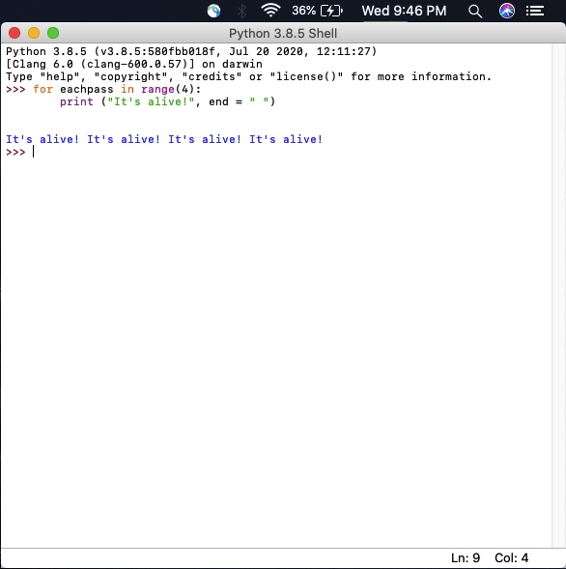

Page 66
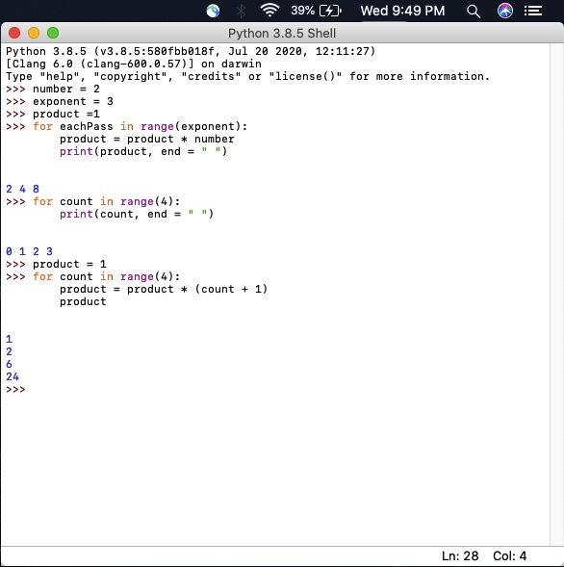

Page 67
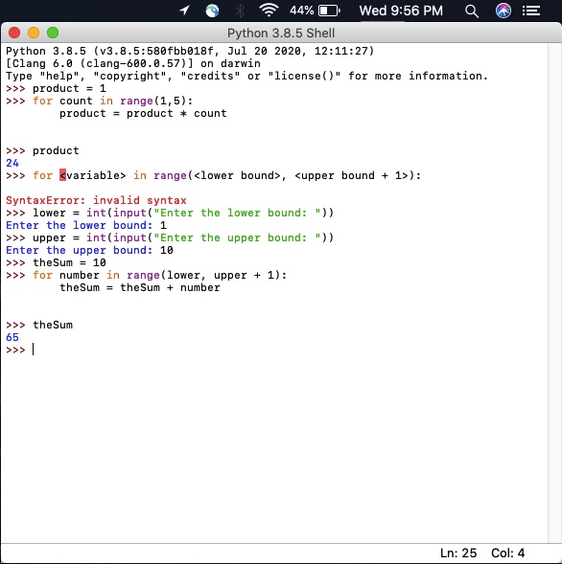

Page 68
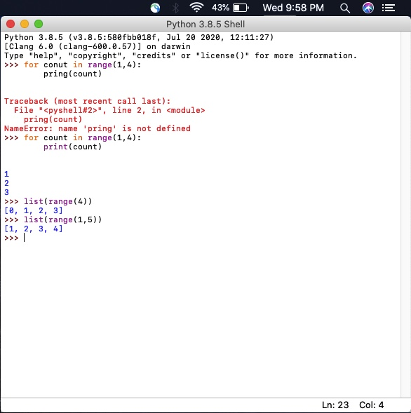

Page 69
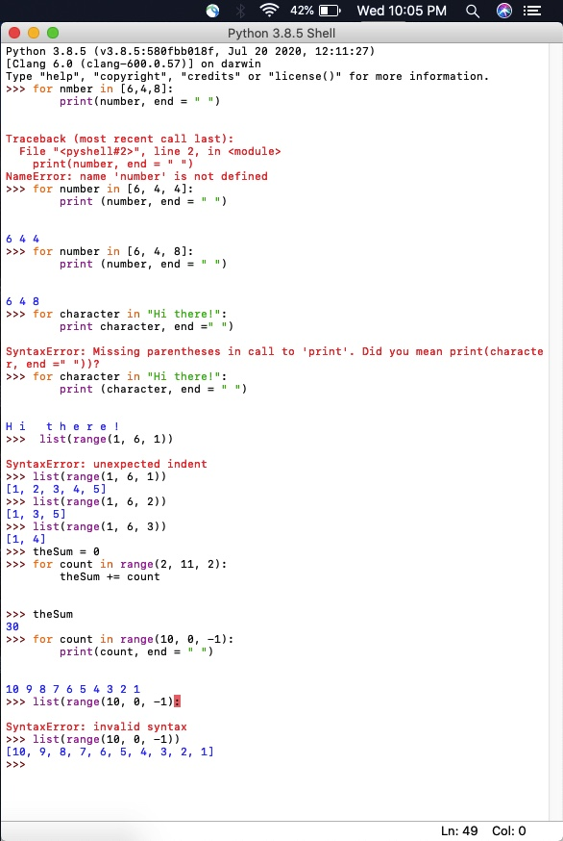

Page 71
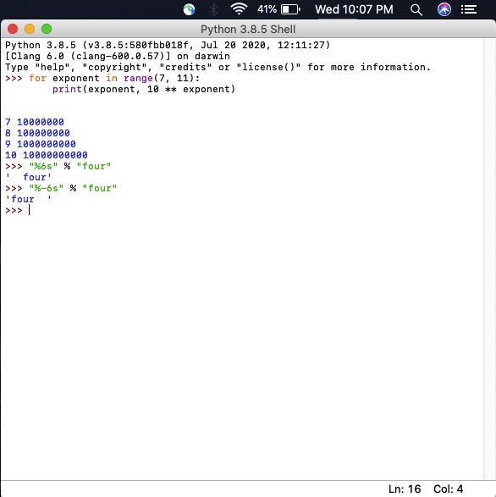

Page 72
